**50% Off Coupon**

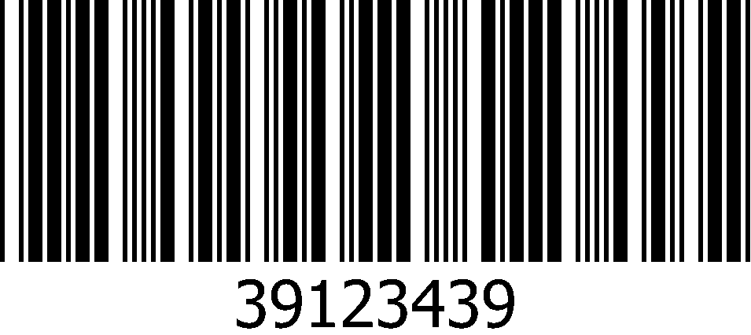

*Here are the terms and conditions to use this Discount Coupon*

*Expiry Date: 30-Dec-2014*