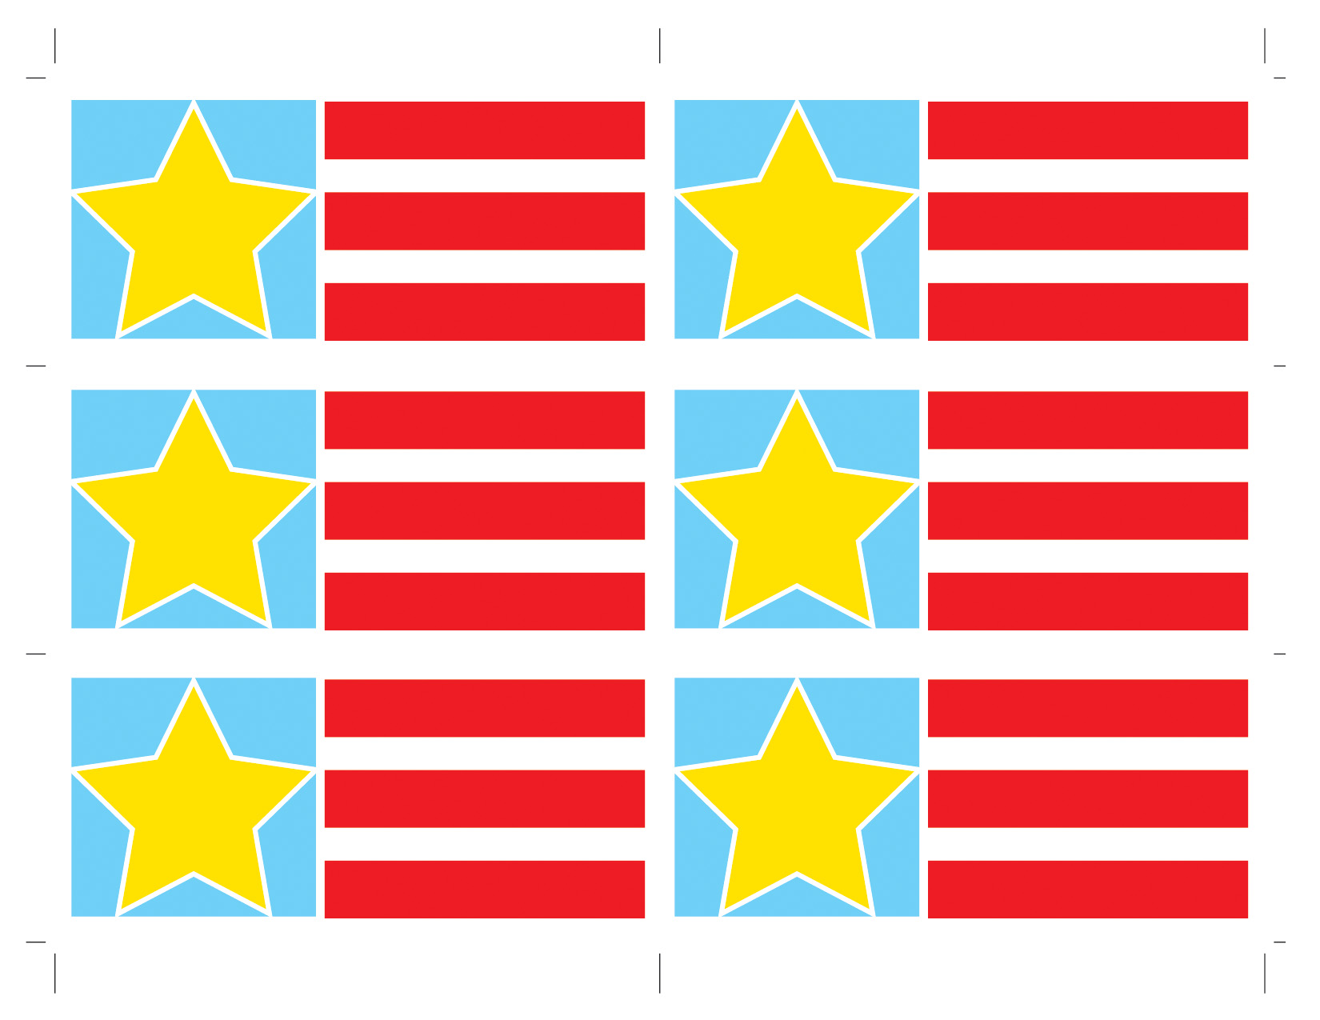

25%

off

25%

off

25%

off

25%

off

25%

off

25%

off

# 9am-6pm

# PETERSON’S SALE

# Saturday, September 7th

# 9am-6pm

# PETERSON’S SALE

# Saturday, September 7th

# 9am-6pm

# PETERSON’S SALE

# Saturday, September 7th

# 9am-6pm

# PETERSON’S SALE

# Saturday, September 7th

# 9am-6pm

# PETERSON’S SALE

# Saturday, September 7th

# 9am-6pm

# PETERSON’S SALE

# Saturday, September 7th