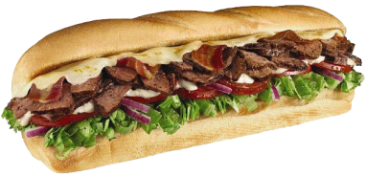

**$1.00**

**OFF**

Get $1 off any regularly priced

footlong sub or 50c off any

regularly priced 6-inch sub.

**Offer expires 11/23/14**

Not valid with any other offer. No cash value. Not for sale. Valid at participating SUBWAY restaurants. One coupon per customer per visit.

**$1.00**

**OFF**

Get $1 off any regularly priced

footlong sub or 50c off any

regularly priced 6-inch sub.

**Offer expires 11/23/14**

Not valid with any other offer. No cash value. Not for sale. Valid at participating SUBWAY restaurants. One coupon per customer per visit.

**$1.00**

**OFF**

Get $1 off any regularly priced

footlong sub or 50c off any

regularly priced 6-inch sub.

**Offer expires 11/23/14**

Not valid with any other offer. No cash value. Not for sale. Valid at participating SUBWAY restaurants. One coupon per customer per visit.

**$1.00**

**OFF**

Get $1 off any regularly priced

footlong sub or 50c off any

regularly priced 6-inch sub.

**Offer expires 11/23/14**

Not valid with any other offer. No cash value. Not for sale. Valid at participating SUBWAY restaurants. One coupon per customer per visit.